Shakespeare Scavenger Hunt
CLUE 2: Hide in Baird’s Room CLUE 2: Hide in Nearby Room

The first you seek, is thy number true,
Find next the false, and thou’st know two.
Three, too, like one, be true to thee.
Until, our trio, acts as key
To unlocketh that which thee must find.
Traverse four years back in time,
Seek out a box, an empty tomb,
Resting yonder, Baird’s sealed room.
Will’s bones lie silent, and so shall thee
Hold tongue, so others may not see
What thou may’st know, with phone turn’st on,
That which is true and what is wrong.
(Nosweatshakespeare’s fifty facts,
May help your quest to quickly pass.)

The first you seek, is thy number true,
Find next the false, and thou’st know two.
Three, too, like one, be true to thee.
Until, our trio, acts as key
To unlocketh that which thee must find.
Tarry not, for short is thine time.
Seek out a box, an empty tomb,
Resting yonder in sealed room.
Will’s bones lie silent, and so shall thee
Hold tongue, so others may not see
What thou may’st know, with phone turn’st on,
That which is true and what is wrong.
(Nosweatshakespeare’s fifty facts,
May aid your quest to quickly pass.)

Shakespeare Scavenger Hunt: Challenge 1
His Personal Life
T | F | Shakespeare was born in April, 1524 to John and Mary Shakespeare.
T | F | Shakespeare had 7 brothers and sisters.
T | F | When Shakespeare was 18, he married Anne Hathaway, age 26, who was already three months pregnant with their first daughter, Judith.
T | F | Shakespeare had three children. His only son, Hamnet, died as a child.
T | F | Shakespeare died on his birthday, April 23rd. He was 68 years old.
T | F | Shakespeare was a prosperous businessman in Stratford and died a very wealthy man.
T | F | Shakespeare’s family crest was a spear on a yellow shield.
T | F | Shakespeare was likely Catholic, even though this religion was illegal in England at the time.

His Professional Life
T | F | Shakespeare wrote over 35 plays.
T | F | Shakespeare refused to write plays with other authors.
T | F | Shakespeare wrote over 150 sonnets. Sonnets always have 15 lines.
T | F | Romeo and Juliet is almost completely written in verse, with only about 10% prose.
T | F | Hamlet, Shakespeare’s longest play, has been translated into Klingon.
T | F | Queen Elizabeth was the only English monarch who watched Shakespeare as an actor in plays.
T | F | Shakespeare never published any of his plays. They were only printed after he had died under the name, “The Second Folio.”
T | F | During Shakespeare’s time, many of the female parts were played by teenage orphan girls.
T | F | Rival acting companies would attend Shakespeare’s plays and attempt to record or memorize the parts so that they could perform the plays with their own acting companies.

His Theatre: The Globe
T | F | Shakespeare’s theater, “The Globe”, was once dismantled and its timber carried to a new location when a dispute occurred with the landowner over the “morality” of performing plays.
T | F | Shakespeare’s Globe theatre burned to the ground after its roof caught fire during a performance of Henry II.
T | F | Shakespeare acted in many of his plays. His acting troupe, called “Lord Chamberlain’s Men, ”was later renamed “The King’s Men”.
T | F | The Globe theatre was a square building with no roof that could hold up to 3,000 people.
T | F | The Globe put flags outside the building to advertise what kind of play was being performed. A red flag for history, white for a comedy, and black for a tragedy.
T | F | Wealthy aristocrats often sat directly on the stage to watch the play, while the poorest “groundlings” stood in the pit area at the front of the stage.
T | F | The Globe Theater was forced to close in 1603 and 1608 because of the plague.
T | F | In 1997, The Globe Theater was rebuilt, close to its original site in Southwark.

TFT
 | F | Shakespeare was born in April, 1524 to John and Mary Shakespeare. (F) 1564
T |  | Shakespeare had 7 brothers and sisters.
 | F | When Shakespeare was 18, he married Anne Hathaway, age 26, who was already three months pregnant with their first daughter, Judith. (F)
T |  | Shakespeare had three children. His only son, Hamnet, died as a child.
 | F | Shakespeare died on his birthday, April 23rd. He was 68 years old. (F)
T |  | Shakespeare was a prosperous businessman in Stratford and died a very wealthy man.
T |  | Shakespeare’s family crest was a spear on a yellow shield.
T |  | Shakespeare was likely Catholic, even though this religion was illegal in England at the time.
Challenge 1 ANSWER KEY

T |  | Shakespeare wrote over 35 plays. T
 | F | Shakespeare refused to write plays with other authors. F
 | F | Shakespeare wrote over 150 sonnets. Sonnets always have 15 lines. F
T |  | Romeo and Juliet is almost completely written in verse, with only about 10% prose.
T |  | Hamlet, Shakespeare’s longest play, has been translated into Klingon. (True)
 | F | Queen Elizabeth was the only English monarch who watched Shakespeare act in plays. (False James)
 | F | Shakespeare never published any of his plays. They were only printed after he had died under the name, “The Second Folio.” (False first folio)
 | F | During Shakespeare’s time, many of the female parts were played by teenage orphan girls. (False)
T | F | Rival acting companies would attend Shakespeare’s plays and attempt to record or memorize the parts so that they could perform the plays with their own acting companies.

T |  | Shakespeare’s theater, “The Globe”, was once dismantled and its timber carried to a new location when a dispute occurred with the landowner over the “morality” of performing plays.
 | F | Shakespeare’s Globe theatre burned to the ground after its roof caught fire during a performance of Henry V. (False—henry 8)
T |  | Shakespeare acted in many of his plays. His acting troupe, called “Lord Chamberlain’s Men, ”was later renamed “The King’s Men”.
 | F | The Globe theatre was a square building with no roof that could hold up to 3,000 people. F
T |  | The Globe put flags outside the building to advertise what kind of play was being performed. A red flag for history, white for a comedy, and black for a tragedy.
T |  | Wealthy aristocrats often sat directly on the stage to watch the play, while the poorest “groundlings” stood in the pit area at the front of the stage.
T |  | The Globe Theater was forced to close in 1603 and 1608 because of the plague
T |  | In 1997, The Globe Theater was rebuilt, close to its original site in Southwark.

KEY CODE IS 5 (true) ; 6 False; 6 True

William Shakespeare
1564-1616

Good friend for Jesus sake forbear,
To dig the dust enclosed here:
Blest be the man that spares these stones,
And curst be he that moves my bones.

Bones in order shall make good,
Arm to hand, leg to foot.
Each bone linked to men of play
As old to new, Tis actor’s way.
Bertram’s name within doth dwell
For him, all’s well that ends well.
Success be found when years, in line,
Spell out thy lady’s sacred shrine.

O. Bertram ---- ---- ---- ---- ----
G. Antonio --- -------- -- ------
A. Romeo ----- --- ------
H. Petruchio --- ------ -- --- -----
M. Macbeth -------
O. Othello -------
C. Richard III ------- --- -----
N. Oberon --------- ------ -----
E. Julius ------ ------
R. Hamlet ------

ANSWER
Richard III (1592-1593)
The Taming of the Shrew (Petruchio) (1593-1594)
Romeo and Juliet (1594-1595)
A Midsummer Night’s Dream (1595-96)
The Merchant of Venice (1596-1597)
Julius Caeser (1599-1600)
Hamlet (1600-1601)
All’s Well That Ends Well (1602-1603)
Othello (1604)
Macbeth (1605-1606)

C-H-A-N-G-E-R-O-O-M
46 – on door

What Can You Unlock? Your Secret Lies Within

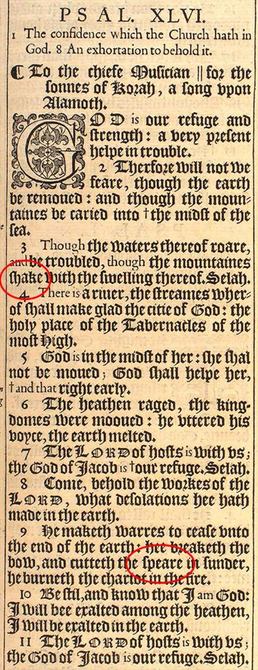
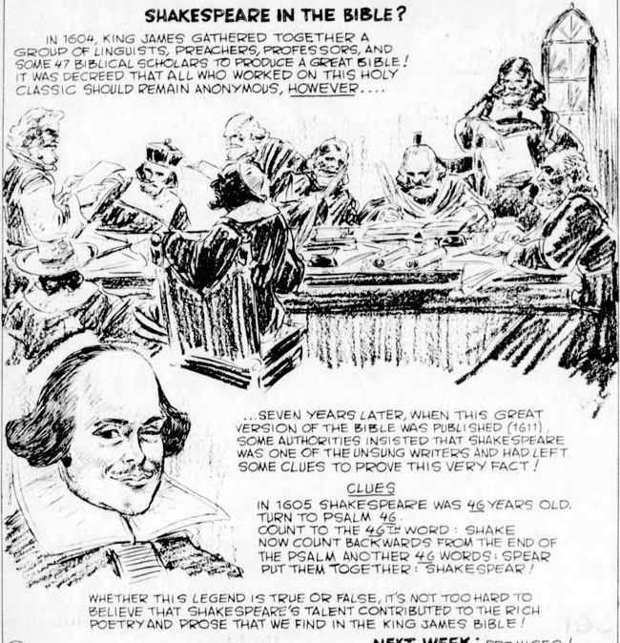

46
1611
46
1611

46
1611

46
1611

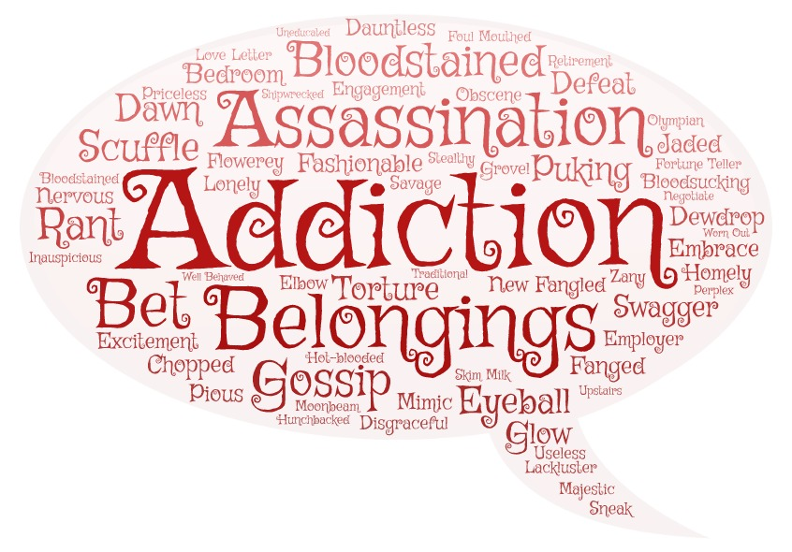

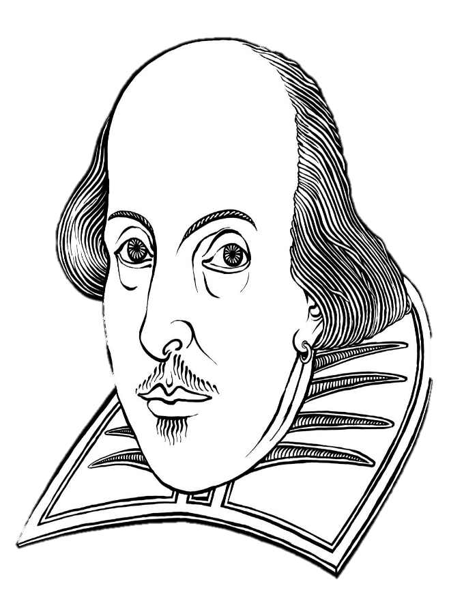

Shakespeare is credited with adding around 1,700 words to the English language. He would add new prefixes and suffixes to old words, combine words to create new ones, and use words common in everyday language that had not yet made their way into print. Some of Shakespeare’s new words are found in the speech bubble. Use them to fill in the crossword puzzle provided by your teacher and solve the accompanying riddle.

Crossword Puzzle: TICKET STUB

1,5 8,7 17,2 22,9 24,7 10,4 2,4 3,9 4,5 6,1
---- ---- ---- ---- ---- ---- ---- ---- ---- -----

Romeo and Juliet
Admit One
GrOUP is Entitled
to 1 Free Popcorn

The King James Bible, published in 1611, is said to have a hidden birthday message for Shakespeare in which Psalm: 46

